**My favourite books **

**Main page | First book | Second book | Contact us**



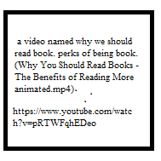

The main goal of this website to share with bookworms my favourite books, short reviews about topic and links to download as PDF.

|  |  |  |  |
| --- | --- | --- | --- |
| **Name of book** | **Author** | **Publishing year** | **Genre** |
| Lord of the Flies | William Golding | 1954 | Allegorical |
| The Catcher in the Rye | J. D. Sallinger | 1951 | Realistic fiction |

Author : Farid Ibrahimli

**First book**

**Main page | First book | Second book | Contact us**

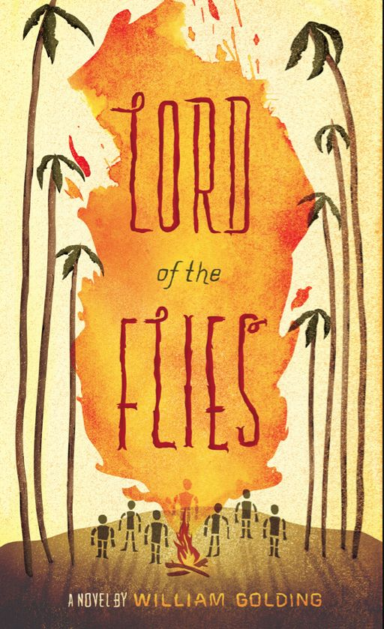

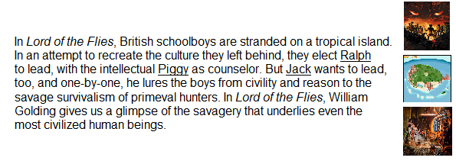

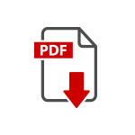

Author : Farid Ibrahimli

**Second book**

**Main page | First book | Second book | Contact us**

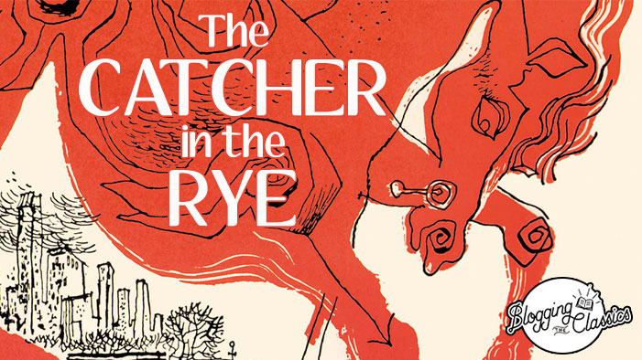

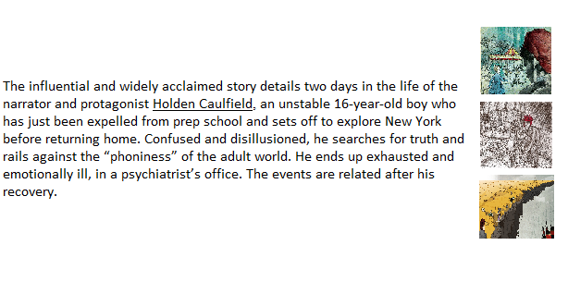



Author : Farid Ibrahimli

**Contact us**

**Main page | First book | Second book | Contact us**

If you want to subscribe to new posts or you have any book suggestions you can share your contact with us:



Author : Farid Ibrahimli